Create a directory by name project1.

Make this directory as a git repository.

Create a file by name test1.py in this directory

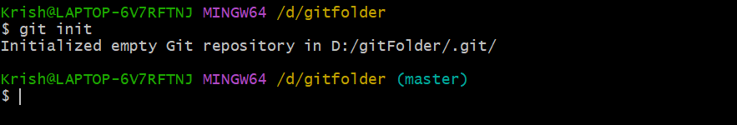

Add 2 lines in the file . git add and then commit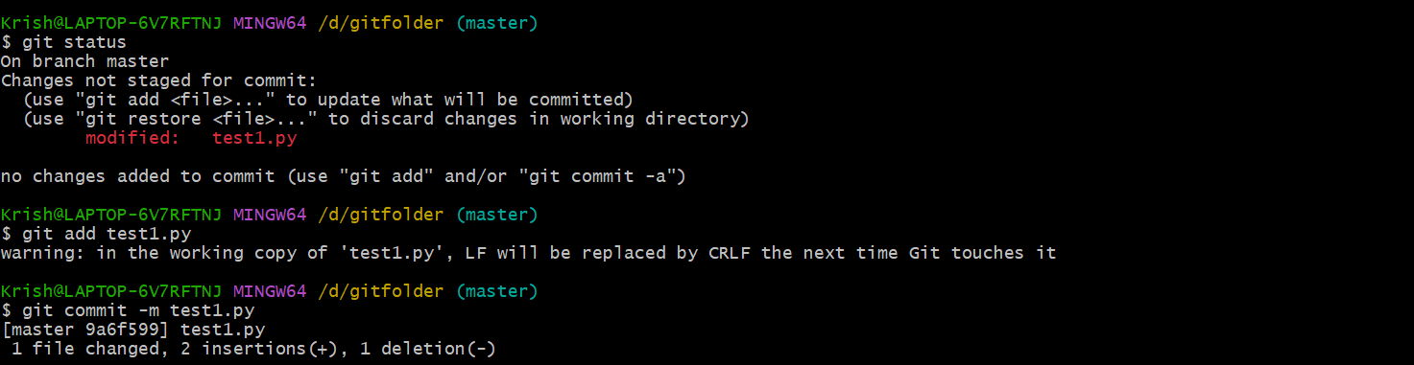

Open the test 1.py file again . then add 2line . git add and commit



Open test1.py file . delete some line and restore by git restore:

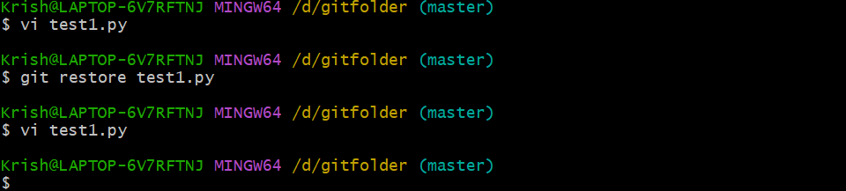

Bring the 4 line version back to work area (commit to work area)

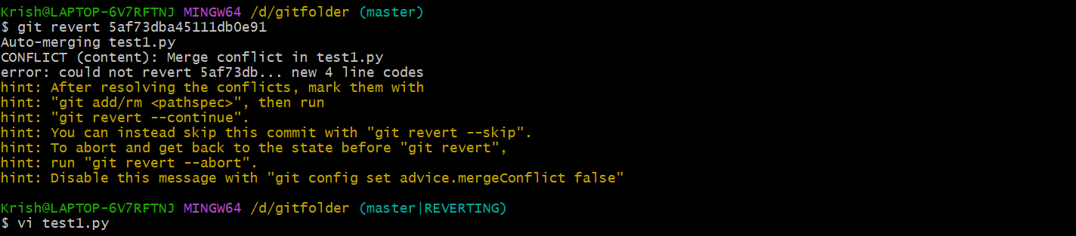

Create a directory by name lms

Initialize it as a git repo

Create a projectinfo.txt file in it , git add and commit

Git status

Git branch

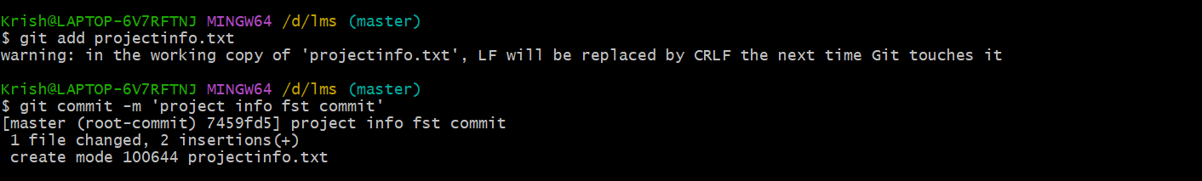

Now create 3 branches home courses and exam

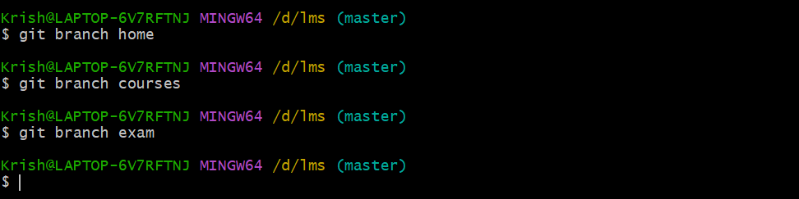

Go to branch and create 2 files with diff name , git add, ait commit cheak with status

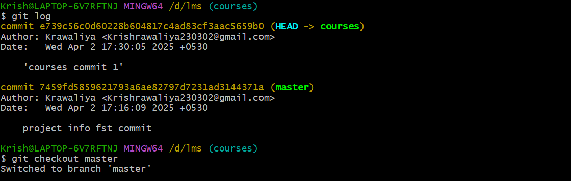

Git add-A

Now go to master branch , merge the home branch

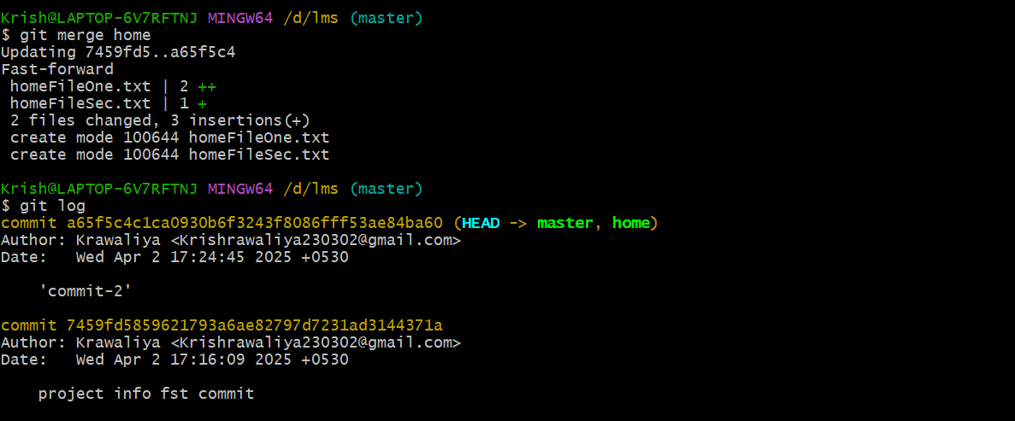

Merge courses to master

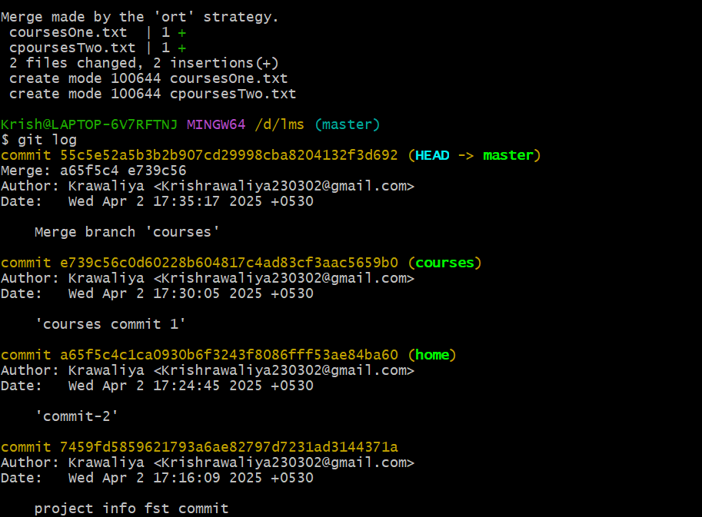

Delete the courses branch

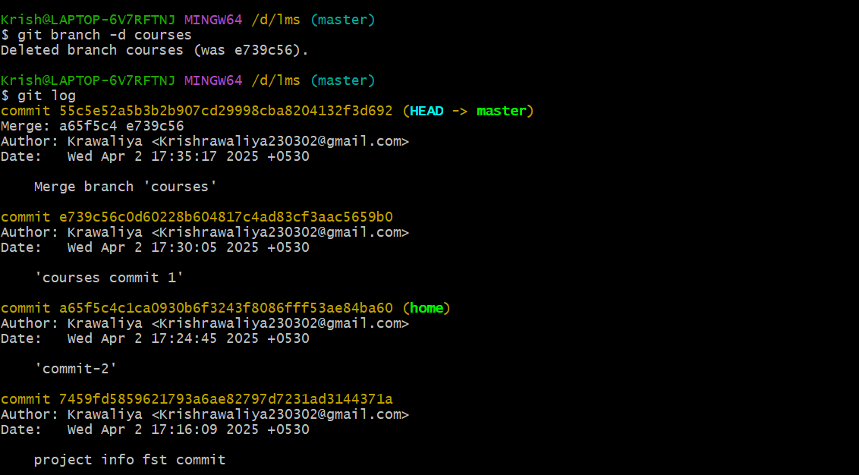

Rename the home to website

